**Compiler Design Mini Project**

Team members:

* Samriddho Das (RA1911003010119)
* Madura Sankar S. (RA1911003010114)
* Rini Ravindran (RA1911003010081)
* Nanditha (RA1911003010080)

Output:

1. String is accepted screen shot

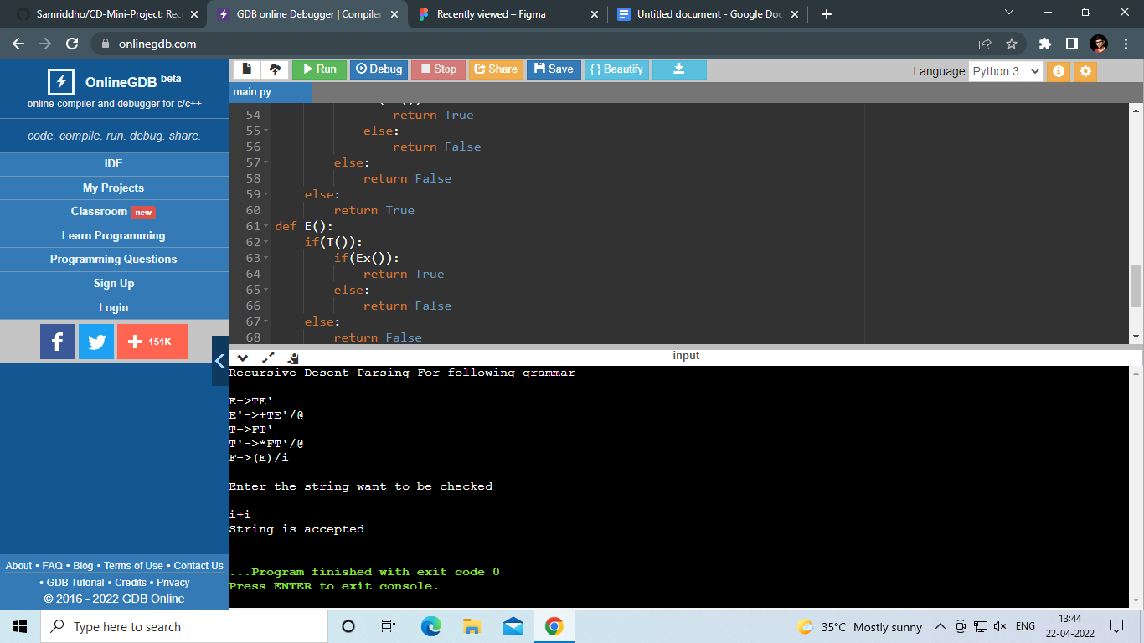

1. String not is accepted screen shot

